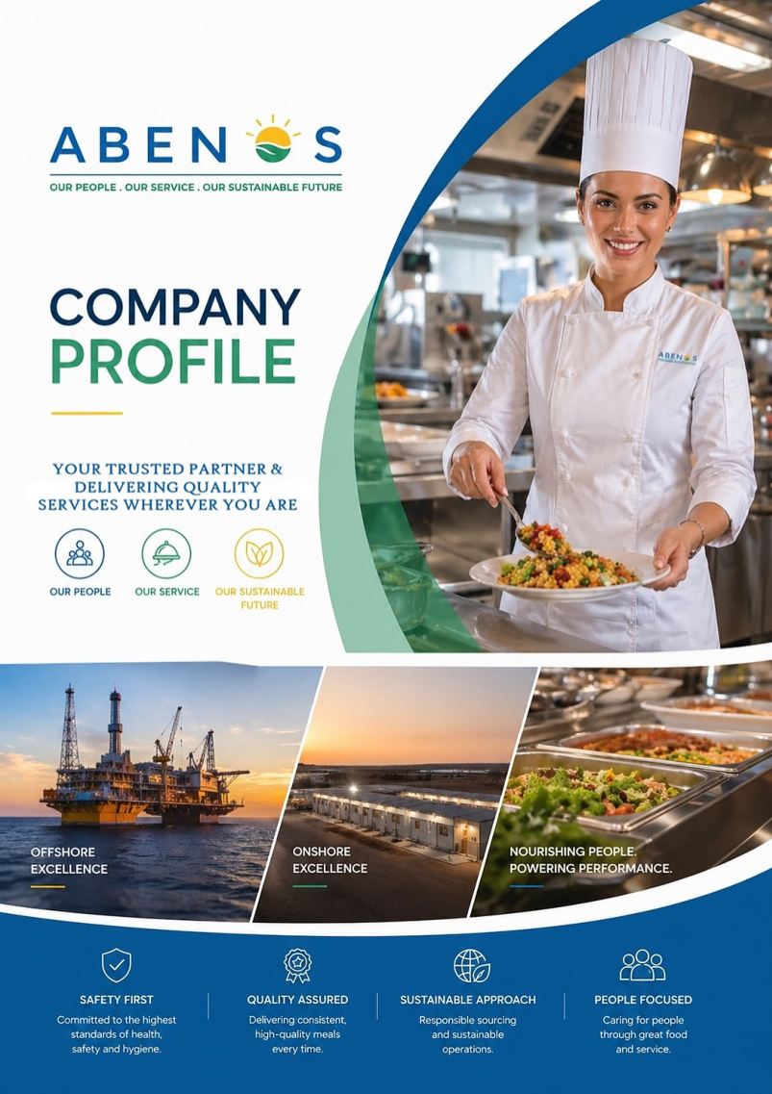
WEBSITE UPGRADE
CONTENT & DEVELOPER BRIEF
Page-wise website copy, content hierarchy, visual guidance and calls-to-action
Prepared from the current ABENOS website and Company Profile V2026 Rev-03

1. Website Upgrade Direction
  - Recommended information architecture for a modern B2B catering and allied-services website.
Primary objective: position ABENOS as a process-driven, quality-focused regional partner for complex onshore, offshore, marine and remote-site operations.

Recommended Main Navigation
- Home
- About Us | Leadership Team | Our Values |
- Sectors We Serve | Regions We Serve
- QHSE & Sustainability
- Life@ABENOS (Career Page)
- Contact Us – 02 Links (Options) Required – Supplier & Clients

Trusted Partners (Home Page)
Flashing | Rolling screen with Client Logos in the bottom

Developer / UX Priorities
- Use operational photography: offshore assets, remote camps, commercial kitchens, provisioning, housekeeping and trained teams. – Pictures should match with the content of the page (for eg: QHSE related pics should be more on QHSE & Sustainability page)
- Keep a persistent 'Request a Proposal' / 'Get in Touch' CTA in the header.
- Surface proof points prominently: established in 2018, ARAMCO/ADNOC/QATAR ENERGY/KJO/KOC -approved service provider, workforce growth and meals served.
- Build service pages so each sector can later be expanded for SEO without redesigning the navigation.
- Use client and approved-vendor logos in responsive grids/carousels, subject to approval.
- Retain ABENOS blue/green/orange brand cues but simplify backgrounds for a cleaner corporate look.

Current Website - Upgrade Approach
The current site already includes Home, About Us, Our Values, Sectors We Serve, Quality, Trusted By and Contact Us. The new site should keep this familiar structure while adding stronger proof points, regional coverage, sustainability, partner support and more detailed offshore/onshore capability content.

2. HOME PAGE
Purpose: establish credibility within 5-10 seconds and direct visitors to sectors, capabilities and contact.

Hero

“There is no love more sincere than food”
*George Bernard Shaw*
A little love, a little butter, and something wonderful happens*

ABENOS delivers reliable services across onshore, offshore, marine and remote-site environments.

Sectors We Serve
About us
- Home

Offshore & Marine Marine

RESCOM Segment

IFM Segment

Trusted By

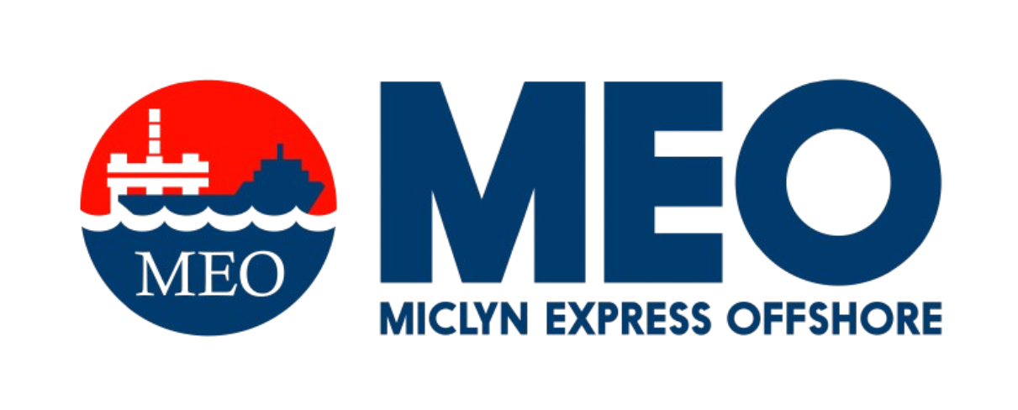
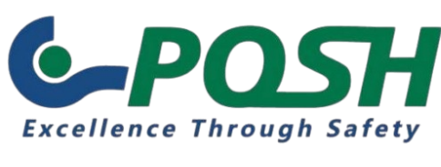

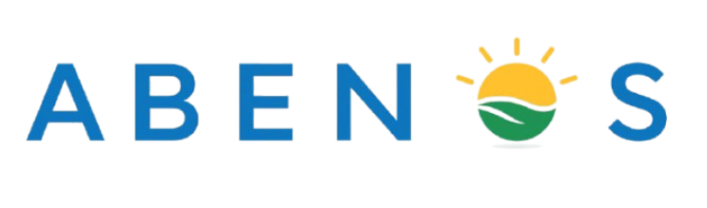

SEGMENTS
- Offshore & Marine (Energy O&M Segment)
- Remote Site & Camp Management (RESCOM Segment)
- Integrated FM Services (IFM Segment)
- Victualing Support Services (VSS Segment)
- Corporate & Industrial Services (CIS Segment)

Supporting line: International service standards with Local expertise. Quality, Safety and People at the center of every operation.
CTA: Request a Proposal | Explore Our Services

Trust / Proof Strip
- Established in KSA in 2018

- Mention the Years in which business started in other countries also (like a road map showing the growth) – KSA 2018, UAE 2024, Qatar – 2024, India 2026, Malaysia

- ARAMCO/ADNOC/QATAR ENERGY/KJO/KOC -approved service provider

- 471 professionals in 2025 (Should Be Flashing pop ups in the top – similar like Sensex update)

- 3,571,494 meals served in 2025 (Should Be Flashing pop ups in the top – similar like Sensex update)

- Regional operations/support across KSA, Qatar, UAE, INDIA and selected Asian markets

Core Solutions
- Offshore | Marine | Islands – Integrated Business Solutions (Catering, Housekeeping, Laundry & Allied Services)

- Onshore Camp Management - Integrated Business Solutions (Camp Administration, Security, Accommodation Management, Catering, Housekeeping, Laundry & Allied Services)

- Facility Management & Support Services – Cleaning, Office Support Services, Technical Maintenance Support Services

- Offshore Catering Manpower Supplies

- Ship Chandelling - Food, Deck Stores & Engine Supplies

- Offshore Logistics | Gate Passes | Sub-Agency Services

- Food Container Support Services for Offshore & Onshore Projects

Closing copy: From daily meal production and crew welfare to provisioning, housekeeping, logistics and manpower support, ABENOS is structured to keep demanding operations running safely, efficiently and consistently.
ABENOS Logo Tagline has been Changed, to be replaced with NEW LOGO
Visual reference: profile cover. Use its offshore/onshore/food mix as inspiration for the website hero.

3. ABOUT US

Journey of ABENOS in 02-03 paragraph

Who We Are
Established in 2018 in the Kingdom of Saudi Arabia, ABENOS is a trusted provider of Catering and Allied Services, supporting complex and critical operations across the onshore and offshore Oil & Gas sectors, marine environments, and remote camps.
ABENOS has achieved many important milestones including widening our operational boundaries beyond KSA and expanded our Footprints in Qatar, the UAE, India, Kuwait, Baharain, etc. ABENOS also has the capability & supporting our Offshore Clients in other Asian countries, including Malaysia, Singapore, Indonesia, China, Taiwan etc.
ABENOS continues to strengthen its regional presence through key industry approvals and strategic growth. We are an ARAMCO-approved service provider in Saudi Arabia, an approved service provider to Qatar Energy (QP and QG) in Qatar, and an ADNOC-approved service provider in the UAE. These credentials reflect our commitment to meeting the stringent requirements of leading energy operators and our ambition to build long-term partnerships across the region.
Our strength lies in combining internationally recognized service standards with experienced, qualified professionals and in-depth local market expertise. Supported by a capable management and operational team with extensive industry experience across Saudi Arabia, the UAE, Qatar, and India, we deliver reliable, efficient, and consistent services tailored to the unique demands of each operating environment.
Our integrated management structure brings together Operations, HSE, HR, Crewing, Procurement, and Logistics to ensure coordinated execution at every stage—from mobilization and workforce deployment to daily service delivery and contract management. This integrated approach enables us to respond effectively to operational challenges while maintaining a strong focus on service quality, safety, compliance, and client satisfaction.

Our Growth Story
From 36 employees and 24,547 meals served in 2020, ABENOS grew to 471 professionals and 3,571,494 meals served in 2025. This growth reflects increasing operational capacity and continued client confidence.

2030 Ambition
Mission: To reach 10,000,000 meals by 2030.

Our Key Leadership Personnel (Country wise & Department wise)
Photo, Country, Department, Experience & Area of Expertise, Vision
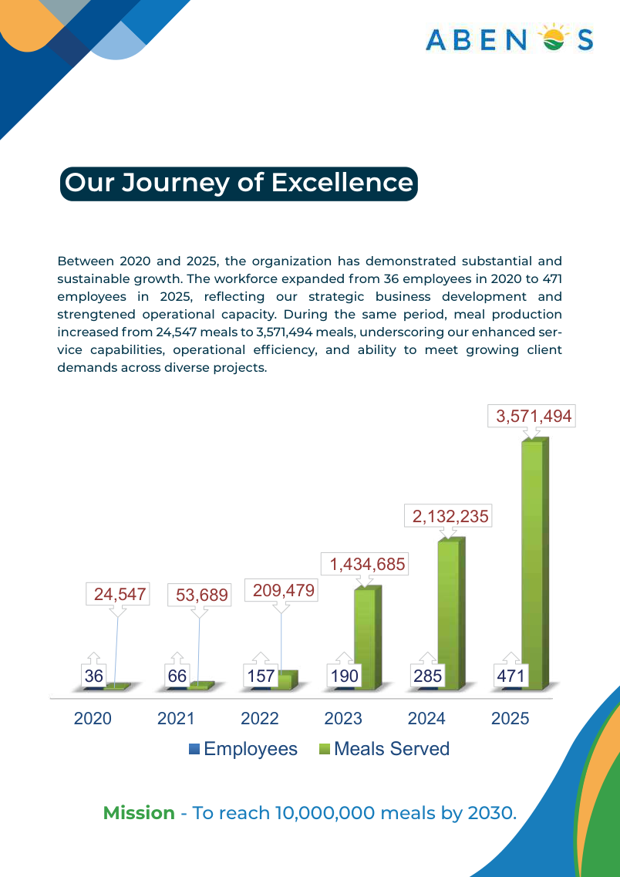
Visual reference: 'Our Journey of Excellence'. Rebuild this as a responsive web chart.

4. SUCCESS PILLARS
People First (INTERNAL & EXTERNAL CUSTOMERS)
Invest in qualified, experienced, and customer-focused professionals through structured onboarding, ethical recruitment, continuous training, and employee engagement. We believe that empowered people are the foundation of consistent service delivery and lasting client relationships.

Service Excellence
Work closely with our clients to understand their needs, focus on the promised services, plan effectively, and mobilize efficiently. Through regular audits, transparent reporting, client feedback, and timely corrective actions, we maintain service standards and drive continuous improvement.

Safety & Quality
Integrate Food Safety, Hygiene, Risk assessment, Employee Training, and Robust QSHSE controls into our daily operations to protect people, maintain compliance, and deliver safe, reliable, and consistent services. ABENOS prefers to set standards above the statutory requirements in Safety & Quality Compliance.

Sustainable Future
Committed to minimizing our environmental impact through responsible sourcing, efficient use of water and energy, waste reduction, and the responsible selection and use of materials across our operations.

Integrity & Partnership
We uphold transparency, accountability, and ethical business practices in every engagement. By working collaboratively with our clients and suppliers, we focus on compliance, dependable service delivery, and building trusted, long-term partnerships.

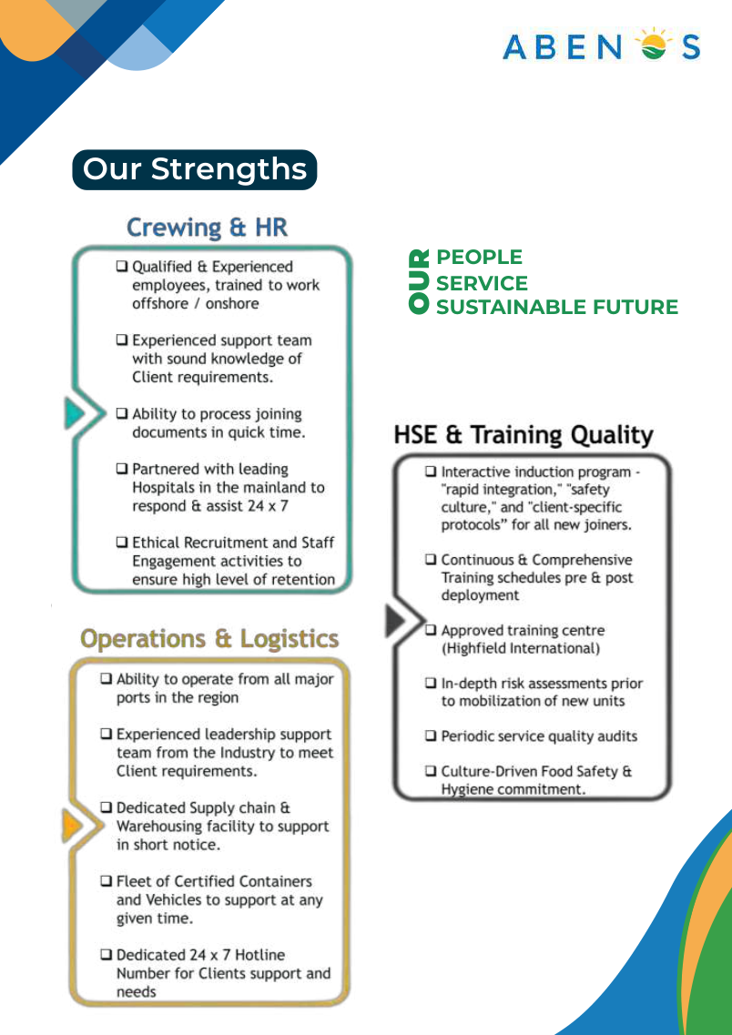
Not important for Website
Visual reference: 'Our Strengths' - People, Service and Sustainable Future can become three signature value pillars.
5 SECTORS WE SERVE (Market Segments | Fields of Expertise | Our Domain | Segments of Expertise)

Offshore, Island & Marine (OIM Segment)

Offshore, Island & Marine (OIM Segment)

Offshore operations demand meticulous planning, operational precision, and strict compliance with safety and quality standards. ABENOS delivers integrated catering and allied services to offshore rigs, vessels, marine installations, and offshore personnel, with a strong focus on operational continuity, food safety, hygiene, and crew welfare.

Our offshore service capabilities include:

Regulatory Compliance: Adherence to applicable maritime regulations, food safety standards, QHSE requirements, and client-specific procedures.

Qualified Personnel: Competent, trained, and experienced teams supported by established quality management systems.

Food Provisioning: Reliable supply of fresh and dry provisions, beverages, and essential consumables to meet offshore operational requirements.

Supply Chain & Inventory Management: Effective cold-chain control, stock monitoring, inventory management, and food waste reduction.

Menu Planning: Balanced, standardized, and rotation-friendly menus designed to meet crew requirements and support nutritional well-being.

Food Safety & Hygiene: HACCP-based controls, temperature monitoring, hygienic food handling, and effective prevention of cross-contamination.

Laundry & Housekeeping: Dedicated laundry and housekeeping services tailored to the hygiene, operational, and accommodation requirements of marine environments.

Chemical Safety & Quality Assurance: Approved cleaning chemicals, safe handling procedures, routine internal audits, inspections, and corrective actions to maintain consistent service standards.

Through structured planning, disciplined execution, and continuous performance monitoring, ABENOS supports safe, efficient, and dependable offshore operations while enhancing the daily experience and well-being of the crew.

Remote Site Camps & Onshore Segment (RESCON Segment)
ABENOS delivers integrated camp management support and catering services for remote locations, workforce accommodation, and large-scale industrial operations. Our service delivery systems are designed to uphold food safety, accommodation hygiene, workforce comfort, and uninterrupted operational continuity while maintaining consistent quality and service standards.
Our service capabilities include:
- Camp Security & Access Coordination: Support for site security coordination and controlled access procedures to promote a safe and well-managed camp environment.
- Commercial Kitchen Operations: Efficient management of large-scale commercial kitchens, supported by structured workflows and standardized operating procedures.
- Food Safety & Storage: HACCP-based food safety management, hygienic food handling, and temperature-controlled storage to preserve food quality and safety.
- Menu Planning & Nutritional Control: Balanced menus, nutritional considerations, and standardized recipes to ensure consistency, variety, and quality across meal services.
- Dishwashing & Sanitation: Mechanized dishwashing, effective sanitation procedures, and structured cleaning schedules to maintain high hygiene standards.
- Housekeeping Services: Comprehensive housekeeping for accommodation units, dining facilities, washrooms, and common areas to ensure cleanliness, comfort, and a pleasant living environment.
- Industrial Laundry: Reliable laundry services designed to meet the volume, hygiene, and turnaround requirements of large workforce populations.
- Resource Efficiency: Use of energy-efficient equipment and water-saving practices to promote operational efficiency and responsible resource consumption.
- Through coordinated service management, trained personnel, and disciplined operating procedures, ABENOS helps clients maintain well-managed camp environments that support workforce well-being, productivity, and business continuity.

Facility Management Services (Integrated FM Segment)

ABENOS provides integrated facility management solutions designed to maintain safe, hygienic, efficient and well-managed facilities through a coordinated approach to soft services, operational support and site services. Our Integrated FM approach focuses on operational continuity, service quality, regulatory compliance, Resource Optimization and client satisfaction.
  - Supply & Maintenance Support Services for Kitchen, Dining, Laundry etc
  - Engineering, HVAC, Plumbing and Technical Support Services
  - Cleaning, Waste Management, Pest Control, Security & landscaping services
  - Waste Management, Manpower Solutions

We emphasize single-point coordination, trained manpower, planned service delivery, routine inspections, performance monitoring, QHSE compliance and continuous improvement to ensure consistent standards across all managed facilities. By integrating essential support services under one coordinated operating model, ABENOS helps clients improve service efficiency, maintain workplace and accommodation standards, and focus on their core business operations.

Victualing & Marine Support Services (VMSS Segment)

We provide a complete range of port-side and offshore support to keep vessels supplied, compliant and ready to sail. From provisions and stores to logistics, documentation and port services, our integrated approach gives ship operators a single, reliable partner for every call.

Ship Supplies
We supply vessels with a full range of quality-assured provisions and stores, delivered on schedule and to specification.
- Deck Stores: Ropes, tools, paints, safety equipment, cleaning materials and other operational consumables essential to deck maintenance and seamanship.
- Cabin Stores: Linen, toiletries, housekeeping items, crew amenities and other supplies that support onboard comfort and welfare.
- Provisions: Fresh, chilled, frozen and dry food items sourced from approved suppliers and handled in line with food safety standards.
Offshore Logistics Support
- Our logistics team coordinates the safe and timely movement of supplies, spares and equipment to vessels at anchorage, at berth and at offshore locations. Through planned scheduling, secure handling and dependable launch and transport arrangements, we reduce delays and help vessels maintain their operating schedules.

Certified Marine Food Containers
- We provide certified containers for the safe storage and transport of marine provisions. Designed to preserve freshness, prevent contamination and meet applicable hygiene and shipping requirements, they ensure food reaches the vessel in optimal condition, whether chilled, frozen or dry.
- Agency Services
We act as a trusted local representative for shipowners, operators and masters, handling port formalities, coordinating with authorities and service providers, and supporting vessels through arrival, stay and departure. Our responsive, round-the-clock coordination minimizes port time and avoids costly disruptions.
- Gate Pass Support
We arrange and manage the permits and clearances needed for personnel, suppliers and vehicles to access port and terminal areas. Our familiarity with port procedures ensures faster approvals, smooth entry and uninterrupted delivery of services to vessels.
- Port Cleaning Services
We offer professional cleaning for vessels while in port, including deck, cabin and common-area cleaning as well as waste and housekeeping support. Carried out by trained crews using approved materials and methods, these services help vessels meet hygiene, safety and environmental expectations.

Why ABENOS
- Single-source convenience: Supplies, logistics, agency and cleaning under one coordinated service.
- Quality and compliance: Certified containers, approved suppliers and adherence to port and maritime regulations.
- Speed and reliability: Dependable turnaround that supports tight port schedules.
- Local expertise: Strong knowledge of port procedures, authorities and operational requirements.

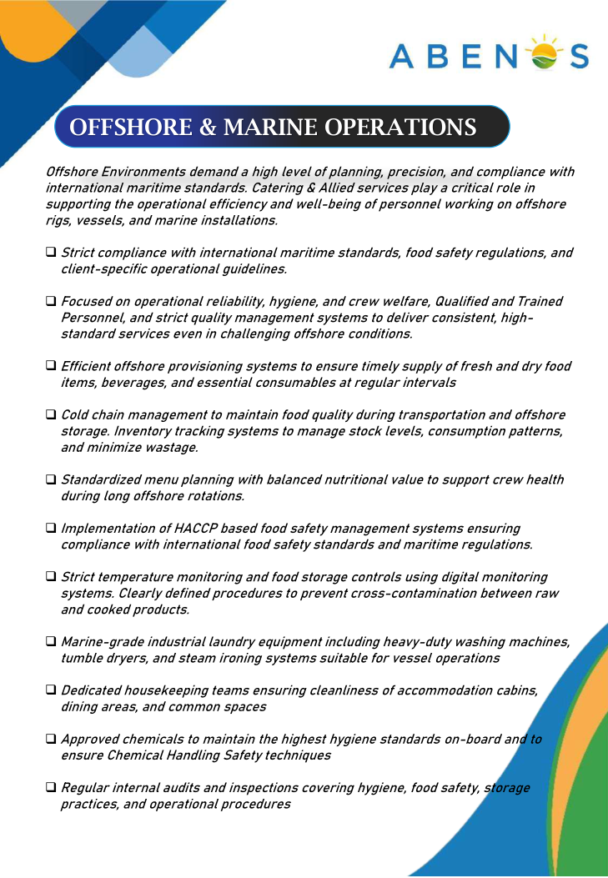
Visual reference: Offshore & Marine Operations.
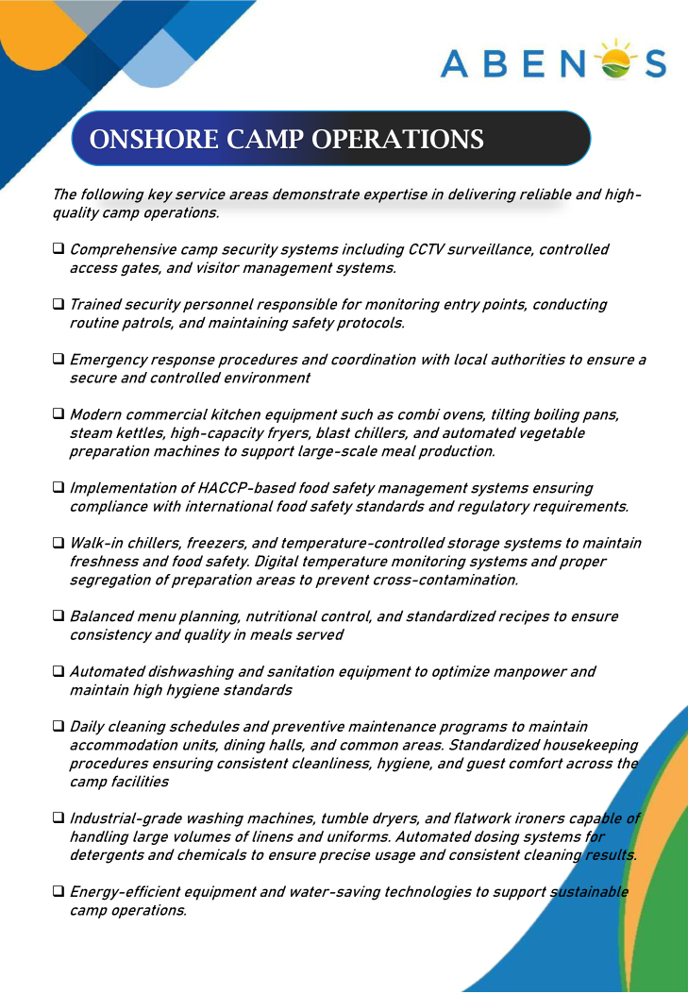
Visual reference: Onshore Camp Operations.

6. QHSE & Sustainability

At ABENOS, Quality, Health, Safety, Environment (QHSE) and Sustainability are fundamental to our business philosophy and operational excellence. We are committed to protecting people, ensuring food safety, safeguarding the environment, maintaining hygienic and secure facilities, and supporting the uninterrupted operations of our clients across the Oil & Gas, offshore, onshore, catering, hospitality, and facilities management sectors.

Our integrated approach combines systematic risk assessments, HACCP-based food safety management, robust hygiene controls, employee training, operational audits, performance monitoring, incident reporting, and continuous improvement. We promote a proactive safety culture built on accountability, regulatory compliance, responsible practices, and the collective commitment of our people.

Our Commitment to Sustainability & Corporate Social Responsibility
ABENOS aims to integrate environmental responsibility, social wellbeing, and ethical business practices into its day-to-day operations through initiatives focused on:
- Food Waste Reduction: Promoting responsible food preparation, menu planning, portion control, surplus monitoring, and waste segregation to minimize food waste across our catering operations.
- Environmental Stewardship: Encouraging efficient use of water, energy, and other resources while promoting responsible waste management, recycling, and environmentally conscious procurement.
- Health, Safety & Employee Wellbeing: Fostering safe working environments, strengthening food safety awareness, supporting employee welfare, and promoting a culture of respect, inclusion, and shared responsibility.
- Community Engagement & Social Responsibility: Encouraging community participation, food donation initiatives where legally permitted and safely managed, and support for local social welfare programmes.
- Responsible Supply Chain: Working towards stronger supplier accountability by encouraging ethical business practices, quality assurance, sustainable sourcing, and compliance with applicable environmental and safety requirements.
- People Development & Awareness: Investing in employee training, skills development, sustainability awareness, and initiatives that empower our workforce to contribute to safer and more responsible operations.
- Continuous Improvement & Accountability: Monitoring operational performance, identifying opportunities for improvement, and progressively strengthening our QHSE and sustainability practices in line with applicable regulations and recognised industry standards.
At ABENOS, we believe that operational excellence, food safety, employee wellbeing, environmental protection, and social responsibility are interconnected priorities. Through responsible practices and continuous improvement, we strive to create lasting value for our clients, employees, communities, and the environment.

Safety Performance
The profile reports zero RFI, RFC, RFSC, RFA, LTI, LWD, First Aid, MTC, RWC and fatalities for the stated 2024 and 2025 reporting periods. Obtain the latest approved QHSE statistics before publishing live counters.

Recommend having Graphic Representation of 3 year statistics, which can be updated every month | Quarter as needed.

Quality Assurance
- Interactive induction covering rapid integration, safety culture and client protocols
- Training schedules before deployment
- Approved training-centre in KSA, to support operations across the GCC & Asia.
- Due diligence & Risk Assessments before mobilization
- Periodic service-quality audits
- Food safety and hygiene commitment
- Monthly operational reporting and quarterly feedback
- Corrective-action plans based on feedback and observations
- Continuous trainings, site visits, visual impacts in the business

Accreditations & Approvals
Create a dedicated grid for current certifications, approvals and vendor registrations. Use the latest valid certificates and exact certification titles supplied by ABENOS.
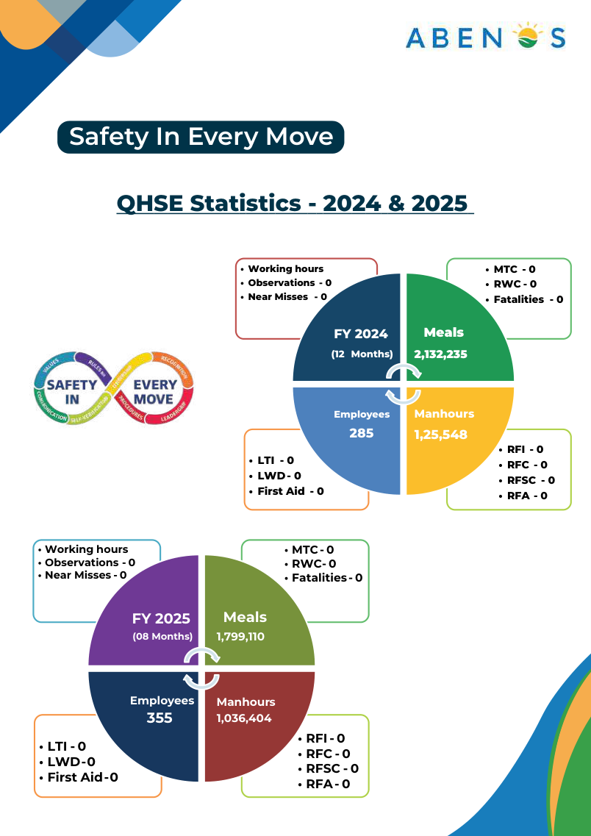
Visual reference: QHSE statistics - rebuild as clean web counters/cards after revalidation.
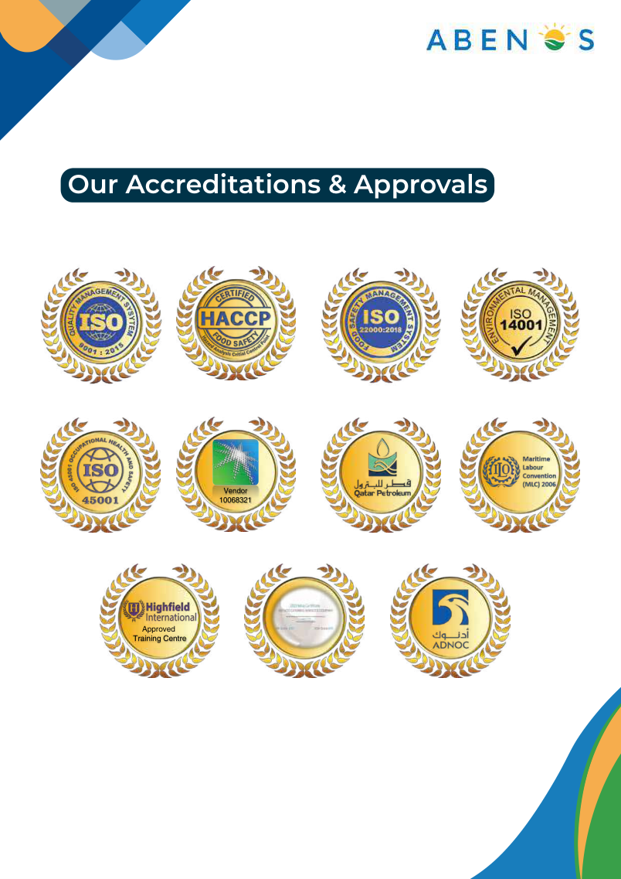
Visual reference: Accreditations & Approvals - use current high-resolution certificate/approval logos.

7. TRUSTED BY
Trusted by organizations operating in demanding energy, marine, drilling and industrial environments. Our client relationships are built on dependable mobilization, consistent service, QHSE compliance and responsive operational support.

Developer Instruction
Use a clean client-logo wall with consistent logo height and white space. Confirm which logos represent current clients, former clients or project references before publication.
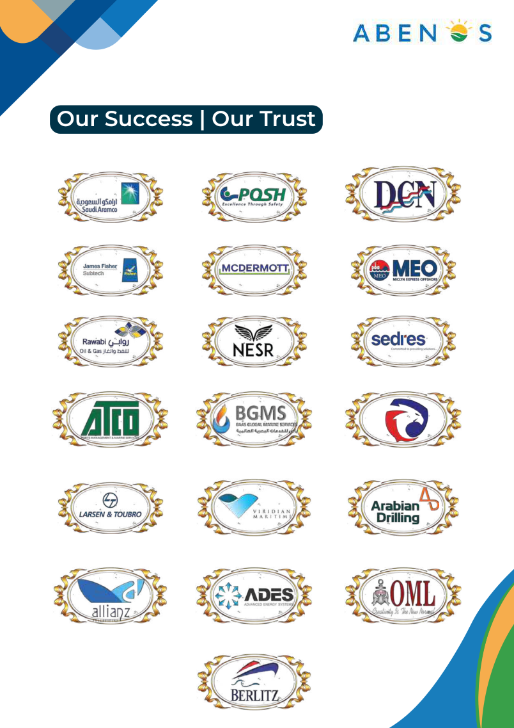
Visual reference: 'Our Success | Our Trust'. Obtain original vector/PNG logos for production.

9. REGIONS WE SERVE (ABENOS SERVICE MAP)
ABENOS was established in Saudi Arabia and has expanded its operational footprint into Qatar and the UAE, while its manpower, supply and support network extends across selected Asian markets.

Interactive Map Labels
- Saudi Arabia – Head Quarter and Aramco Approved Service Provider in core operations; offshore/onshore catering; logistics, gate-pass and sub-agency support
- Qatar – Qatar Energy approved Service Provider with strong regional footprint in offshore catering/manpower support
- United Arab Emirates – ADNOC approved Service Provider with strong regional footprint in offshore/onshore catering; logistics, gate-pass and sub-agency support
- India – ONGC Registered Service Provider & Regional Presence in Offshore, Onshore Catering, logistics, manpower support etc
- Bahrain - regional presence/support as applicable
- Kuwait – KOC approved Service Provider,
- Khafji – KJO approved Service Provider
- Malaysia & Singapore - Offshore catering manpower & Victualling support
- China & Taiwan - supply/sourcing/support network as applicable
- Indonesia - Offshore catering manpower & Victualling support
- Nigeria - Offshore catering manpower & Victualling support
- Ghana - Offshore catering manpower & Victualling support
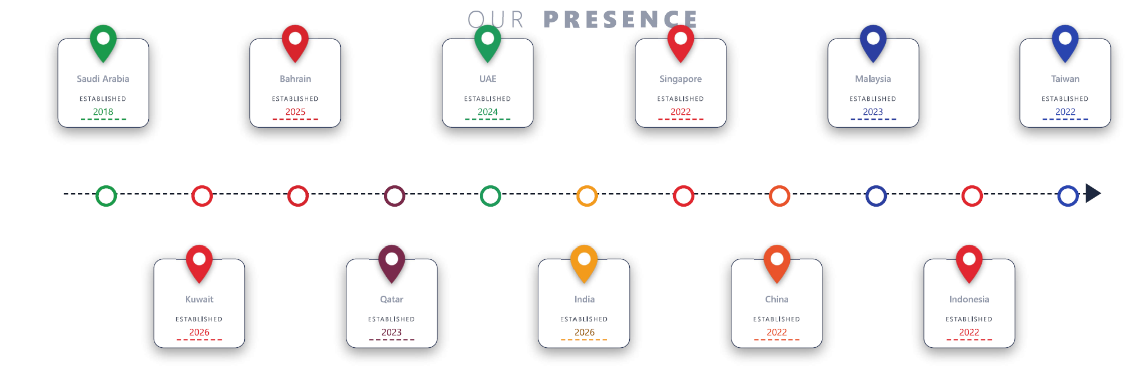
The profile map shows Saudi Arabia, Bahrain, Qatar, UAE, India, China, Singapore and Taiwan. The live site should distinguish 'office/presence', 'service coverage' and 'supplier/manpower network' to avoid overstating a legal or physical presence. – also to show the year of establishment in each country in a sequence
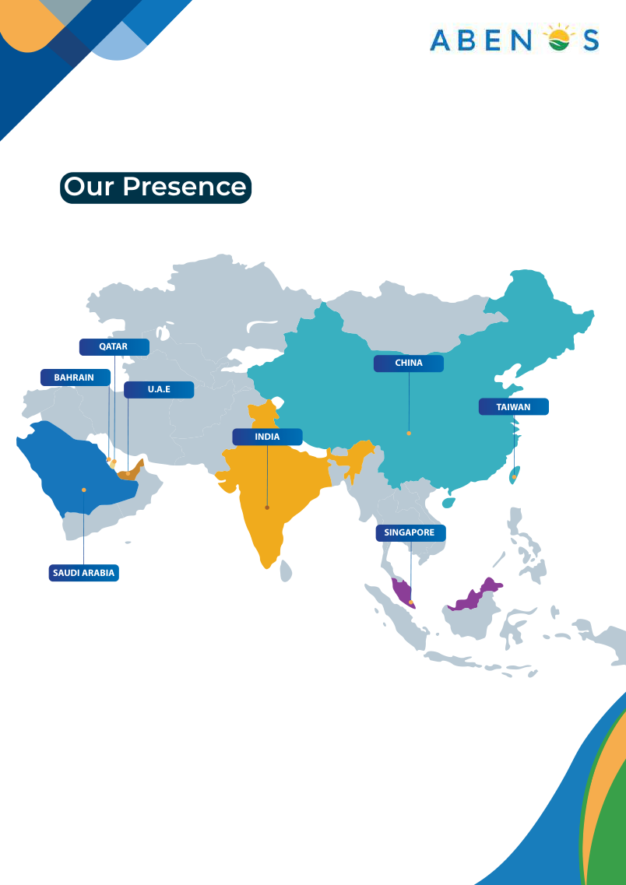
Visual reference: 'Our Presence'. Rebuild as an interactive map with a clear legend.

10. CONTACT US

Talk to ABENOS about catering, camp management, offshore manpower, ship chandelling, logistics or allied support requirements. Our regional team can review your scope and coordinate the right operational response.
Region | Contact | Email | Telephone
Saudi Arabia | Vedraj Mendon –  Vice President | vedraj.mendon@abenos.com | +966 13 802 1006 Ext. 111 | +966 583 734 217
United Arab Emirates | Satheesh Thilak - Country Manager | satheesh.thilak@abenos.com | +971 50 81 28 758
Qatar | Nelson Samson - Operations Head | nelson.samson@abenos.com | +974 70 166 174
India | Narendra Asawale | Narendra.asawale@abenos.com
Kuwait
Bahrain

Enquiry Form (BUSINESS SUPPORT FOR CLIENTS)
- Name
- Company
- Email
- Phone / WhatsApp
- Country / Region
- Service Required
- Project / Vessel / Camp Location
- Estimated manpower or POB (optional)
- Message / Scope Summary
- RFQ/SOW upload (optional)
- Consent checkbox

(BUSINESS SUPPORT FOR VENDORS)
- *Supplier Expression of Interest (EOI) Form*
- Section – 1 Basic Company Information
Legal Company Name
Country of Registration – Dropdown List of countries
Business Registration – CR Number, Chamber of Commerce, License etc
Tax ID Number - VAT ID & Certificate | Corporate Tax
ICV | IKTAWA Registration & Score – as per dropdown list of countries
Company Website.

- Section 2: Contact Details
Primary Contact Person Name - Full Name | Designation / Job Title | Company Email Address | Phone / Mobile Number | Company Physical Address

- Section 3: Business & Service Profile
Category of Supply (Dropdown - Choose Primary)
Food & Non-Food Raw Materials & Components
Office Supplies & Equipment
Facilities & Maintenance Services
Logistics, Freight & Warehousing
Professional Services & Consulting
Marketing, Advertising & Events
Other *(Please specify)*
- Quality Certifications & Compliance (Checkboxes)
ISO 9001 (Quality Management)
ISO 27001 (Information Security)
ISO 14001 (Environmental)
ISO 45001 (Health & Safety)
None / In Progress
Other *(Specify)
- Automatic Post-Submission Communication – to be linked to email
- Portal On-Screen Confirmation
“Thank you for submitting your Expression of Interest!"
Your submission reference ID is #SUP-2026-[AutoNumber]. Our Procurement Team will review your application. If your profile matches our current business needs, we will reach out to you with next steps.

Developer Notes
- Route enquiries to a monitored group mailbox with automated acknowledgement.
- Add click-to-call and click-to-email on mobile.
- Add office maps only after exact current addresses are confirmed.
- Add spam protection and a privacy notice.
- Current website/profile show differing .co/.com conventions in places; confirm the official public domain and group email before launch.
Should be Separate for Clients and Suppliers
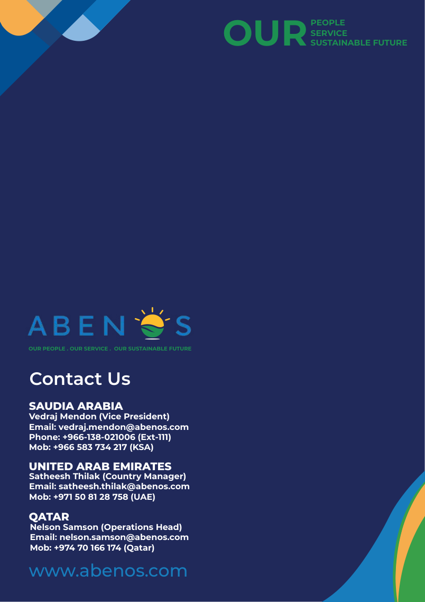
Visual reference: latest profile contact page.

11. SUSTAINABILITY CONTENT BLOCK

Sustainable Sourcing
- Prioritize local and seasonal ingredients where practical
- Select suppliers with responsible and ethical practices
- Source sustainable seafood
- Offer varied plant-forward menu options

Eco-Friendly Operations
- Water-saving practices in food preparation and dishwashing
- Energy-efficient appliances and lighting
- Partnerships with local sustainable businesses

Responsible Packaging & Utensils
- Compostable/biodegradable materials where suitable
- Reusable service items where practical
- Minimize excess packaging and prefer recyclable materials

Waste Management & Reduction
- Smart inventory and menu planning
- Composting partnerships where available
- Waste segregation and recycling
- Donation of safe, unserved surplus food where legally and operationally feasible
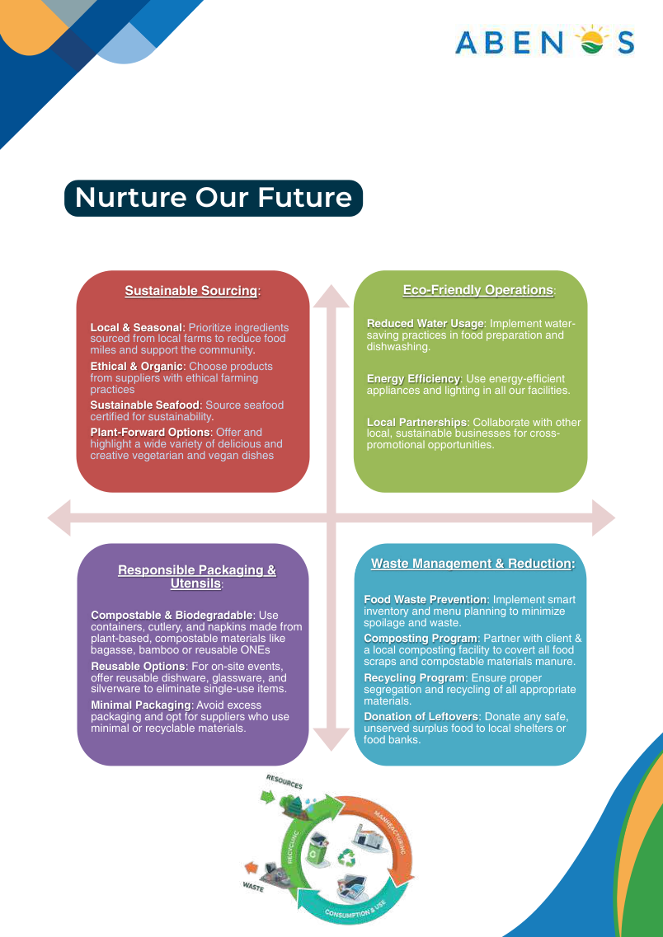
Visual reference: 'Nurture Our Future'. Rebuild as four clean web cards.

13. WEBSITE ASSET & LAUNCH CHECKLIST
Item | Requirement
Brand assets | ABENOS logo in SVG/AI/EPS + PNG; brand colors; favicon.
Photography | Original high-resolution offshore, onshore, food, kitchen, housekeeping, warehouse and team photos.
Client logos | Current approved logos and status/permission confirmation.
Partner logos | Approved-vendor logos and correct legal names.
Certificates | Latest valid certifications/approvals with exact titles and validity.
QHSE figures | Latest approved statistics and reporting period.
Locations | Confirmed office addresses and map pins.
Contacts | Confirmed titles, numbers, group enquiry email and WhatsApp.
Legal | Privacy/cookie notices as applicable, website terms and consent wording.
SEO | Page titles, meta descriptions, schema, keywords and image alt text.
Technical | Mobile-first layout, performance, SSL, backups, spam protection, analytics, Search Console, sitemap and redirects.

Recommended Footer
ABENOS Catering Services Co. | Catering & Allied Services | Saudi Arabia • Qatar • UAE | Quick Links | Services | Contact | Privacy

14. SOURCE & MANAGEMENT REVIEW NOTES
This brief is a website-ready editorial restructuring rather than a verbatim copy of the presentation. It preserves the latest profile's facts and service themes while organizing them for web use.

Primary Source
ABENOS Company Profile V2026 Rev-03 (19 pages): company positioning, services, presence, growth, QHSE, sustainability, clients, partners, processes, accreditations and contacts.

Before Publishing
- Revalidate all QHSE statistics and periods
- Confirm ARAMCO approval wording and registration details
- Confirm certification names/scope/validity
- Confirm client and partner logo permissions/status
- Define each regional presence accurately
- Confirm office addresses and public contacts
- Confirm official website domain and group email
END OF DEVELOPER BRIEF

